ITCOA2-33 PROJECT

Eduvos | [Company address]

Londiwe Mtshweni, Lwazilwenkosi Gumede, Tendani Makhokha

# Deliverable 1: Planning and Design

## Task division and collaboration

All members of the group

Responsible for designing the overall network architecture, including virtual switches, routers, and firewalls. They will also handle the virtualization setup and configuration using Windows Server 2019 on the Oracle virtualization platform.

All members of the group

In charge of planning the IP addressing scheme and network segmentation. This includes deciding on IP ranges for various subnets, defining VLANs, and ensuring proper network isolation.

All members of the group

Responsible for determining the required virtual machines and their respective operating systems. They will consider the server roles, applications, and services that need to be virtualized and select appropriate OS versions for each VM.

All members of the goup

Tasked with defining and implementing the security measures for the virtualized environment. This includes access control, firewall configurations, encryption, and any other security measures to ensure data protection and compliance.

All members of the group

In charge of researching and implementing tools and technologies that simplify network management tasks, such as virtual machine provisioning, monitoring, and updating.

## Identify the requirements of the network infrastructure.

The requirements for the Midrand Threads network infrastructure include:

Improved Scalability:

The virtualized network infrastructure should be easily scalable to support the company's expansion in terms of customers, apps, and services.

Improved Resource Management:

The virtualization solution should allow for more effective allocation and usage of network resources like as processing power, storage, and network bandwidth.

Increased Security:

To secure sensitive data and guarantee compliance with industry requirements, the virtualized environment should incorporate increased security features such as access control, network segmentation, and firewall protection.

High Availability:

The network architecture should be built to minimize downtime while also providing redundancy for key applications and services.

Administration Simplified:

The virtualization solution should make network management tasks like provisioning new virtual machines, monitoring network performance, and applying upgrades easier.

## Define the scope of the assignment.

The scope of this assignment is to upgrade the existing network infrastructure for Midrand Threads to a virtualized environment. The new virtualized network will be accessed by employees to manage network resources, ensure data security, and accommodate the growing number of users and applications. The virtualized network will be hosted using Windows Server 2019 and will aim to provide a more flexible and scalable solution.

## Design the network architecture, including virtual switches, routers, and firewalls.

As it is not physical network connection, a virtual network does not follow traditional networking regulations. As a result, all network devices that communicate with one another use internet technologies. The network is as vast as the internet itself. A virtual network employs cutting-edge technology to establish a wirelessly expanded network. This includes the following:

vSwitch Software:

Virtualization software on host servers that allows you to set up and configure a virtual network.

Virtual network adapter:

Creates a gateway between network infrastructure.

Virtual machines and devices:

Instruments that connect to the network and allow various functionality.

Servers:

Part of the network host infrastructure.

Firewalls and security:

Virtualization software on host servers that enables the setup and configuration of a virtual network is known as "vSwitch software."

Virtual network adapter: Builds a bridge between different types of network infrastructure.

Devices and virtual machines: Tools that connect to the network and provide a range of functions.

The network host infrastructure includes servers.

Security and firewalls: Designed to track and thwart security threats.Designed for monitoring and stopping security threats.

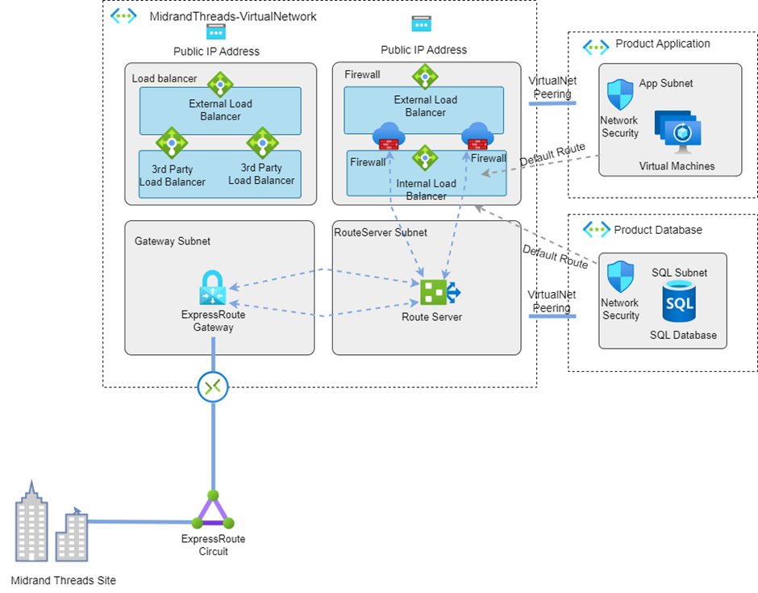

The Virtual network contains the following components:

1. A pair of 3rd party Network Virtual Appliance firewalls
2. A pair of 3rd party Network Virtual Appliance load balancers
3. ExpressRoute Gateway
4. Route Server
5. Two public Load Balancers for the Network Virtual Appliances
6. Two Public IPs Addresses
7. One Internal Load Balancer

## Plan the IP addressing scheme and network segmentation.

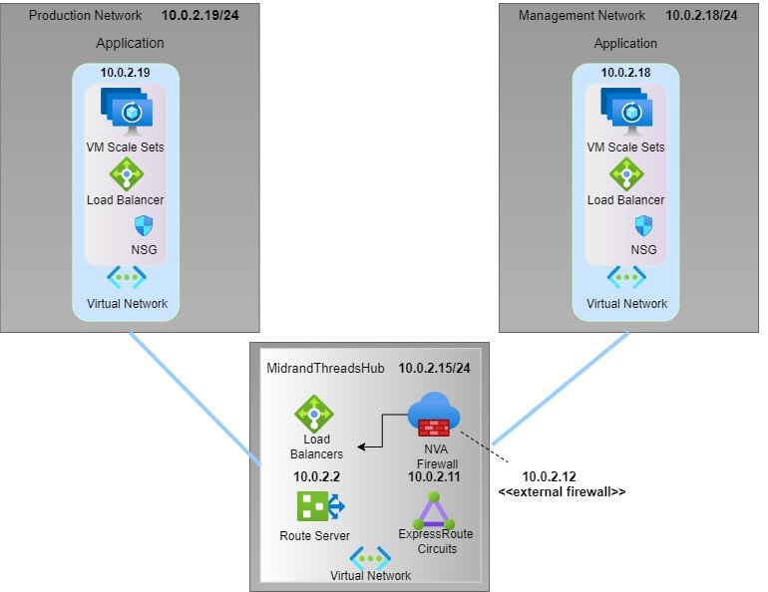

For the IP addressing scheme and network segmentation, a sub netted IPv4 addressing scheme that supports the various segments required for Midrand Threads' virtualized network infrastructure will be designed. This will help with structured resource application, security, and network management.

### Network Segments

Management Network:

192.168.10.0/24 Subnet (The network uses the first 24 bits; the remaining 8 bits are utilized for host addresses.)

Access point: 192.168.10.1

IP address range reserved: 192.168.10.2 to 192.168.10.10 (for networking devices)

Range for DHCP is 192.168.10.11 to 192.168.10.50.

(This segment will have IP addresses ranging from 192.168.10.1 to 192.168.10.254. 192.168.10.1 is the gateway for this segment, acting as the point of entry and departure for communication. For networking equipment, the IP addresses 192.168.10.2 through 192.168.10.10 are set aside. Dynamically generated IP addresses in the range of 192.168.10.11 to 192.168.10.50 will be issued to devices on this network segment that are configured to use DHCP.)

Production Network:

192.168.10.0/24 Subnet (The network uses the first 24 bits; the remaining 8 bits are utilized for host addresses.)

Access point: 192.168.10.1

IP address range reserved: 192.168.10.2 to 192.168.10.10 (for networking devices)

Range for DHCP is 192.168.10.11 to 192.168.10.50.

(This segment will have IP addresses ranging from 192.168.10.1 to 192.168.10.254. 192.168.10.1 is the gateway for this segment, acting as the point of entry and departure for communication. For networking equipment, the IP addresses 192.168.10.2 through 192.168.10.10 are set aside. Dynamically generated IP addresses in the range of 192.168.10.11 to 192.168.10.50 will be issued to devices on this network segment that are configured to use DHCP.)) (A. Zakari, 2019)

## Determine the required VMs and their operating systems.

The required VMs and their operating systems are determined based on the requirements of the business. The VMs are sized appropriately to meet the needs of the applications and services that will be hosted in the virtual environment. The operating systems are chosen based on the security requirements of the business and the compatibility with the applications and services.

Management:

OS: Windows Server 2019

Assigned IP: 192.168.10.11 (The format of this IP address is in line with IPv4 addressing conventions. The choice of the IP address (192.168.10.11) and its segment (Management Network) implies a certain design for network organization.)

Role: Active Directory, DNS, DHCP (Active Directory is used for managing users and resources, DNS for translating domain names, and DHCP for automatically assigning IP addresses. The combination of these roles suggests the VM is acting as a central part of the network's infrastructure.)

Production Application:

OS: Windows Server 2019

Assigned IP (Server 1): 192.168.20.50 (This is assigned to the first VM machine and devices within the same subnet will be able to communicate with this VM using this IP address.)

Assigned IP (Server 2): 192.168.20.51 (This is assigned to the second VM and it allows devices within the same subnet to communicate with it.)

Role: Hosting critical production applications

|  |  |  |
| --- | --- | --- |
| **Virtual Machine** | **Operating System** |  |
| Domain Controller | Windows Server 2019 | Managing user authentication and policies |
| File Server | Windows Server 2019 | Storing and sharing company files |
| Web Server | Windows Server 2019 | Hosting Internal or external company websites |
| Database Server | Windows Server 2019 | Managing company databases |
| Application Server | Windows Server 2019 | Running various business applications |
| Remote Desktop Services (RDS) | Windows Server 2019 | Providing remote access for users |
| Network Monitoring & Management VM | Windows Server 2019 | Monitoring network performance |

## Define the security measures to be implemented.

The security measures to be implemented are defined in accordance with the security requirements of the business and designed to protect sensitive data and to ensure compliance with industry regulations.

Access Control:

* Implement Active Directory (AD) for centralized authentication.
* Role-Based Access Control (RBAC) to define user roles and permissions.

Network Segmentation:

* Divide the network into different segments or Virtual LANs (VLANs) to isolate critical parts of the network.

Firewall Protection:

* Host-based and network-based firewalls to filter and control traffic.

Encryption:

* Use encryption protocols like HTTPS for secure communication.
* Encrypt sensitive data at rest.

Intrusion Detection and Prevention System (IDS/IPS):

* Keep an eye out for harmful activity on the network, and warn or prevent users about potential hazards.

Regular Security Audits and Updates:

* Regularly review security configurations, conduct vulnerability assessments, and apply security patches and updates.

Backup and Disaster Recovery Plan:

* Regular backups of critical data and applications.
* A proper disaster recovery plan to ensure quick restoration in case of a failure.

By implementing this design and these measures, Midrand Threads' new virtualized environment will provide the scalability, resource efficiency, security, and high availability they require. It also simplifies the management of their network, meeting all the listed requirements.

# Deliverable 2: Configuration and Implementation

## Windows Server 2019 setup:

The Windows Server 2019 is an operating system that integrates Azure services into on-premises systems. Multiple levels of security incorporated into the operating system enable various situations, boost current investments, increase security, and reduce business risk. (Microsoft.com, -).

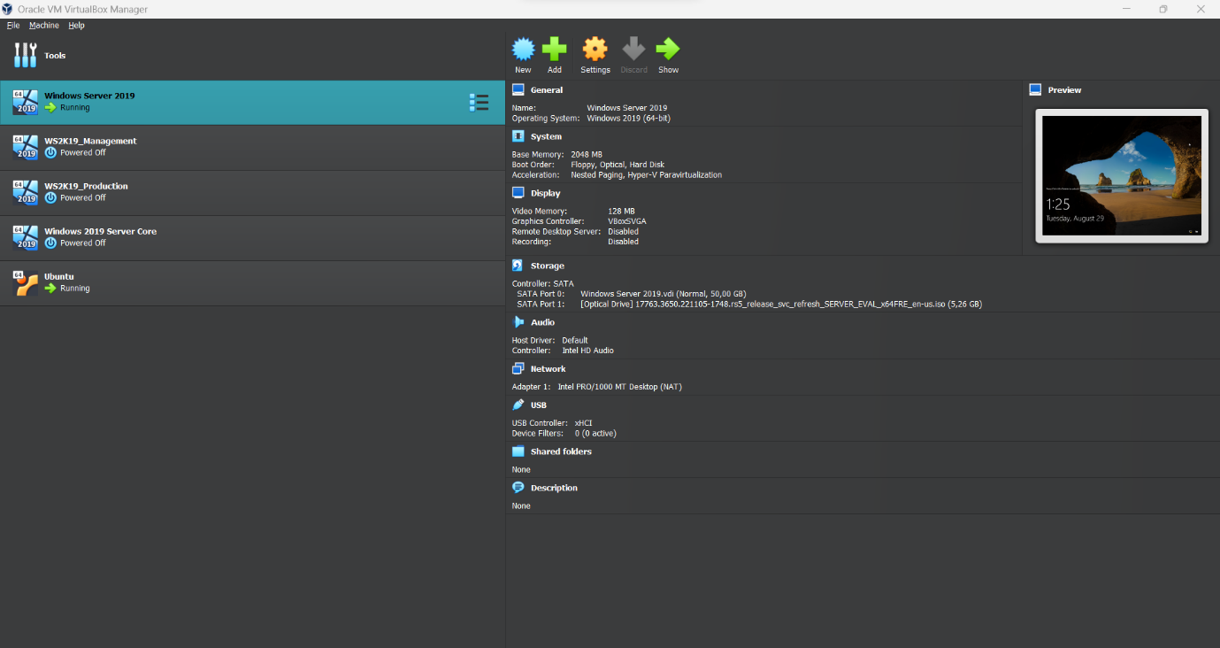

## Virtual switch, router, and firewall configuration:

Virtual Switch Configuration

Communication between virtual computers and a physical network is made possible by a virtual switch. these procedures to set up a virtual switch (Mark Henderson, 2020):

* Activate the Hyper-V Manager.
* Click on your Hyper-V host under "Hyper-V Manager" in the right-hand window.
* Click on "Virtual Switch Manager" in the Actions window.
* Depending on your network needs, select the appropriate virtual switch type (External, Internal, or Private).
* To configure the switch, follow the wizard's instructions, being sure to choose the network adapter that will be linked to the virtual switch.

Router Configuration

* Communication between several virtual networks or segments is made possible by a virtual router. Router configuration procedures.
* Activate the Server Manager.
* Go to Add roles and features and click.
* Install the necessary features by selecting the "Remote Access" role in the wizard.
* Open "Routing and Remote Access" from the Tools menu after installation.
* In the console, right-click your server and select "Configure and Enable Routing and Remote Access."
* Use the wizard to configure routing (e.g., LAN routing, NAT, VPN).

Firewall Configuration

* Using a third-party firewall solution or using Windows Firewall to manage traffic between virtual machines are both options. How to set up Windows Firewall:
* Launch the Control Panel.
* "System and Security" > "Windows Defender Firewall" should be selected.
* On the left sidebar, select "Advanced settings."
* Set up inbound and outgoing rules as necessary to permit or deny particular traffic.

## VM creation and operating system installation:

How to Install Windows Server 2019 using Virtual Machine

Microsoft Server 2019 can be installed on a physical server, or virtualization programs can be used to install and experience it on a desktop or laptop computer (Bagci, 2022).

<https://www.sysnettechsolutions.com/en/install-windows-server-2019-oracle-vm-virtualbox/>

1.      Creation of Windows server VM in VirtualBox.

* To begin installing the Windows server virtual machine, launch VirtualBox and select New or press CTRL+N.
* You can select either the Guided Mode or the Expert Mode in the new Create Virtual Machine window that appears. For our lab, we are use the Guided Mode.
* Type the VM's name here.
* Choose the folder that will house the VM Hard Disk files; I left mine as the default.
* Select Microsoft Windows as the Type.
* Version as Windows 2019 (64bit), other Windows Server versions are available here. Windows 2016 is one illustration (64bit)
* After entering the aforementioned information, select Next. A screenshot of a computer

  Description automatically generated

2.      Specify the Memory.

However, if you intend to use the VM for more tasks, you may need to increase the RAM in accordance. You must now define the memory for the VM.

5.      Attach the windows server image to the virtualbox.

* Click storage under the same VirtualBox settings.
* Select the Empty Disk from the storage devices list.
* To select a disk file, click the Disk symbol in the attributes.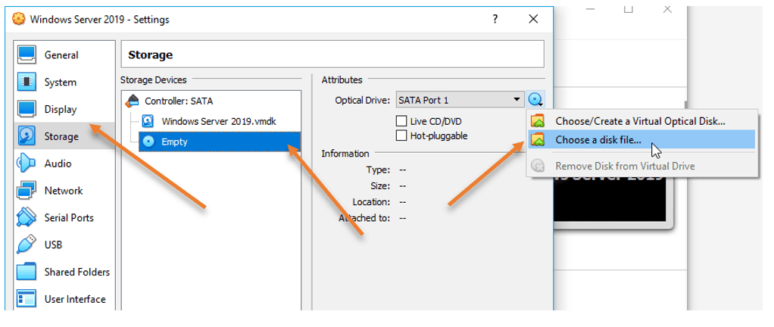
* Attach the ISO that we previously downloaded, then click "OK."

* Right-click the virtual machine and select "start."
* Select the associated ISO image from the start-up disk and press the start button. The Windows server image will start when the VirtualBox instance does.A screenshot of a computer

  Description automatically generated

6.      Begin the windows installation.

The Windows installation screen displays after a short while. After selecting your language, click Next.

You can now select Install.

7.      Choose the Version – GUI or CLI.

On the screen, there will be many Windows Server 2019 versions. To prevent mistakes, you should use a little caution here.

Choose Desktop experience if you want to install Windows Server with a GUI. If you prefer to use a CLI, choose one of the other options.

We chose Windows Server 2019 Standard evaluation since we require GUI access (Desktop Experience)

After selecting your preferred version, click Next.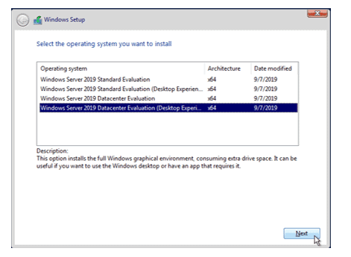

Click Next after agreeing to the license agreement.

Select "Custom" for the installation..

Select the previously defined hard disk, then click Next.. 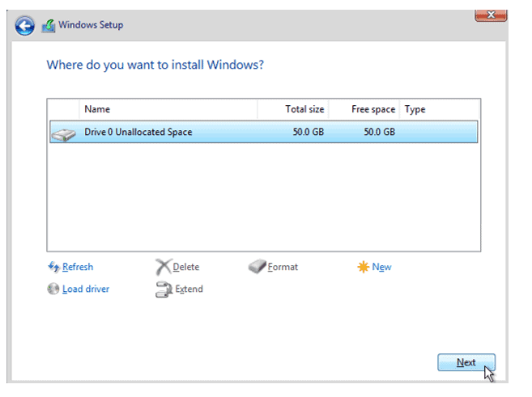

The installation of Windows Server will now start; it will take some time to complete.

8.      Setup the admin password.

You will be required to enter the Administrator password after the installation. Choose an administrator password, then select Finish. (Sidheeq, 2021).

## DHCP and DNS services configuration:

DNS Configuration

### How to install the DNS role in Windows Server 2019/2016.

The Active Directory role is typically implemented alongside this one.

Add Roles and Features can be found in the Server Manager.

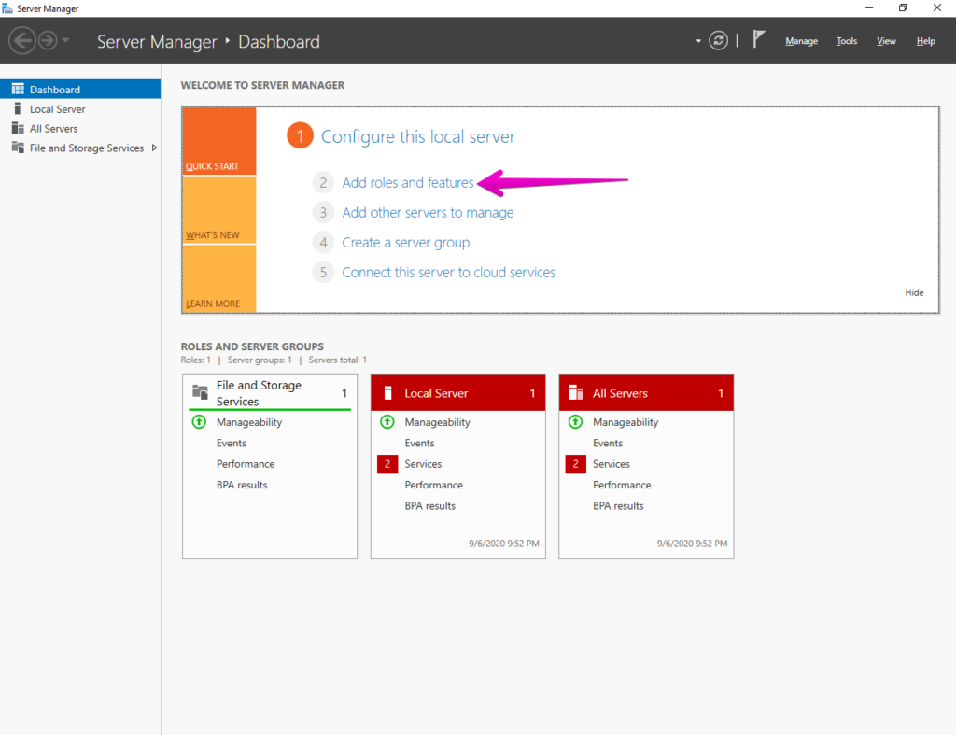

* Include roles and features.
* Click Next to go further.

Select the installation type now. In this instance, we'll employ a feature- or role-based installation.

* Choose the installation type.
* Choose the machine that will host the DNS server.

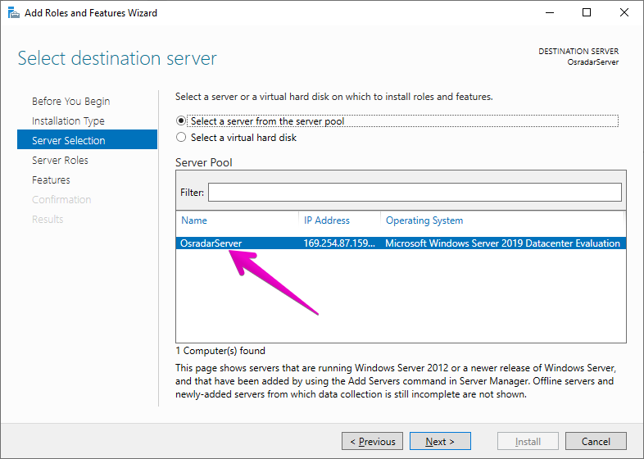

Choose a server.

You can see the DNS role is already set up in the image below. If not, tick the box and go through the wizard's instructions.

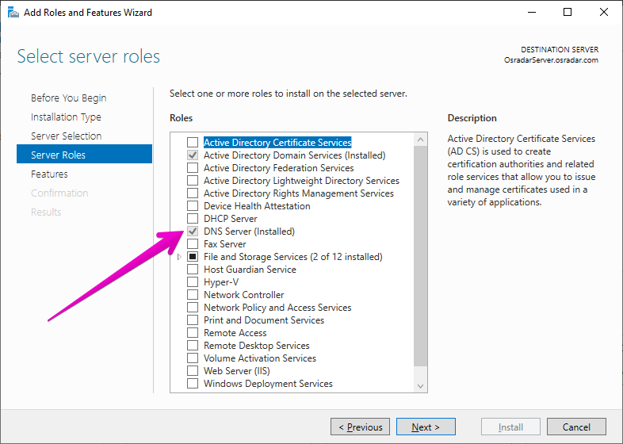

### Setting up a DNS server in Windows Server 2019/2016.

* The DNS role configuration should be done after the installation has been confirmed.
* We'll use the Server Manager to accomplish this.
* select the Tools option.
* then select DNS.

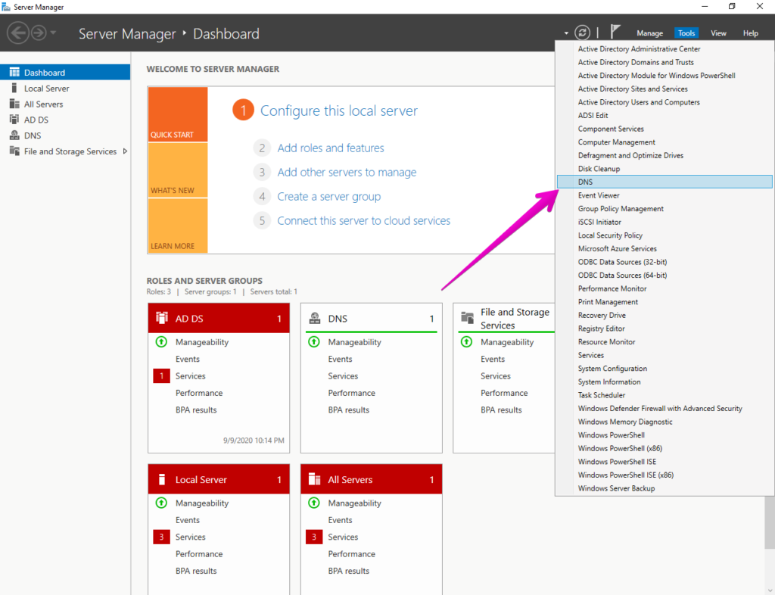

* Select DNS
* The DNS manager will then appear.
* Right-click on the server's name.
* Select Configure a DNS Server after that.

* begin setting up the DNS server.
* Instantaneously, the DNS Server Configuration Wizard will appear.
* Click Next to proceed.

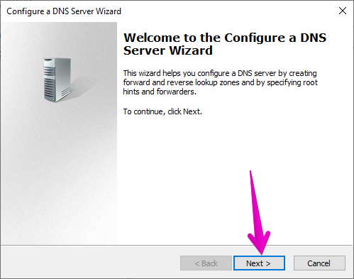

The best option for the zone to be used on the server should now be chosen. It is advised to create a forward lookup zone if you use tiny networks.

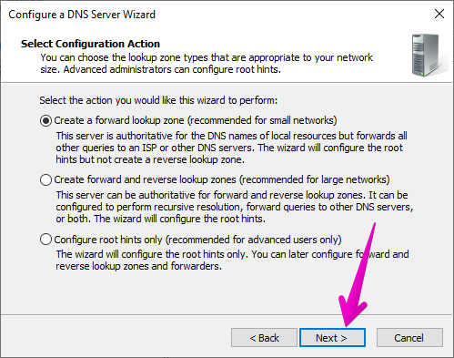

Decide on the right kind of search area.

Set the primary server's location. This time, the zone is maintained by the server.

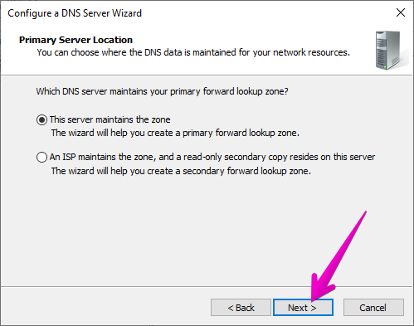

Set the primary server's location.

After that, give the zone a name.

Setting up how to get updates is now necessary. It is advised to use the first choice for security reasons.

To receive updates, choose a mode.

The DNS server can be set up as a temporary reseller using this option. Since it enables our DNS server to contact other external DNS servers, this is really exciting. This applies to records that it is unable to resolve on its own.

Include the external DNS server's IP address.

Include the external DNS server's IP address.

The assistant will have completed his duties after this stage. The assistant will have completed his duties after this stage.

You will now be able to see the region that was correctly generated. As a result, Windows Server now supports DNS server administration. (Roger, 2020).

DHCP Configuration

* Dispatch Server Manager
* Click characteristics and roles.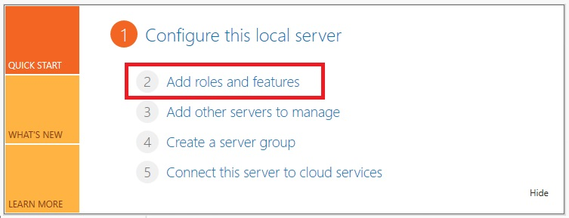
* As you progress through the wizard to the Server Roles page, click Next.
* Mark the DHCP Server box.
* When a pop-up window appears, select Add Features.
* To continue, select Next.

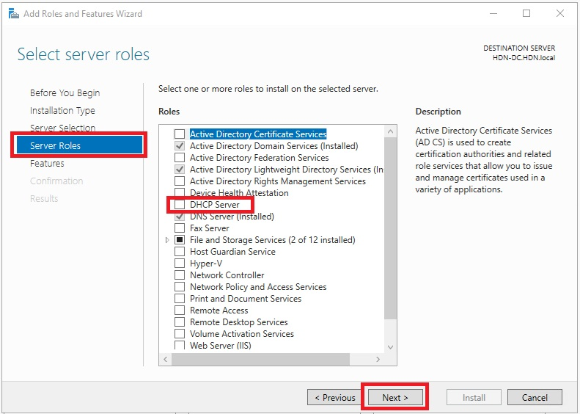

* Click Next through the wizard until you reach Install.
* Click Install.

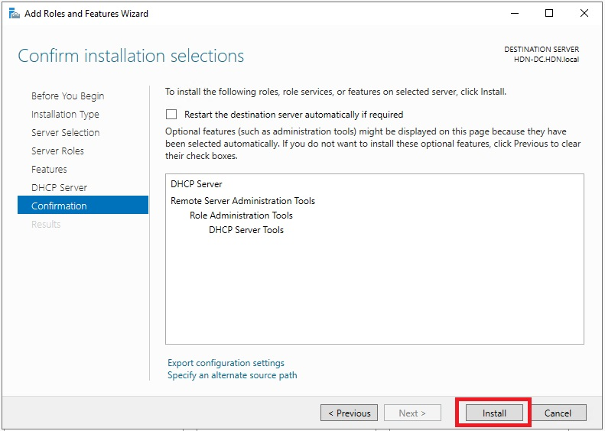

* After the installation is complete, select Finish configuring DHCP.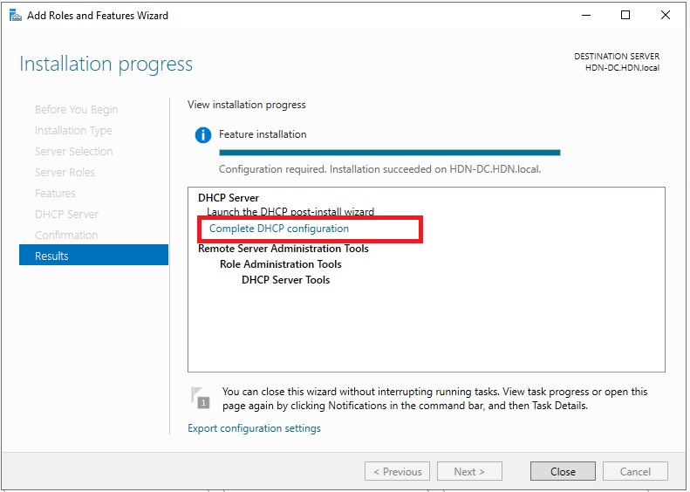
* A DHCP Post-Install Configuration Wizard is present here.
* Choose Next.
* To commit, click.
* You should then be able to see that the configuration is complete.
* After clicking Close, the installation is complete.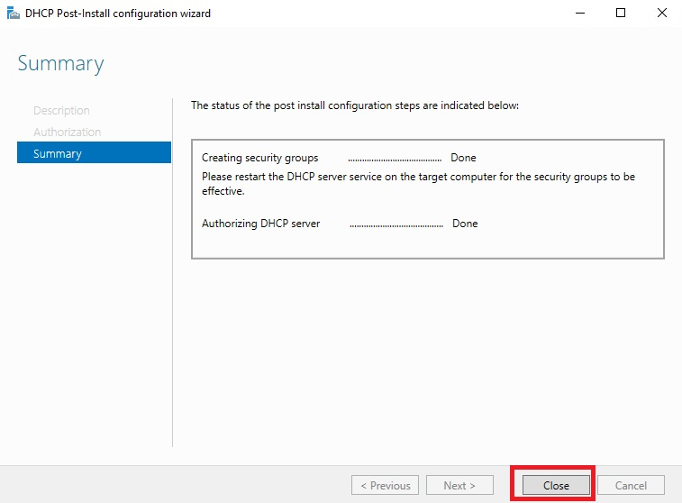

### Let’s get started with the configuration of the DHCP Role

* Activate Server Manager if it isn't already active.
* After selecting Tools, click DHCP.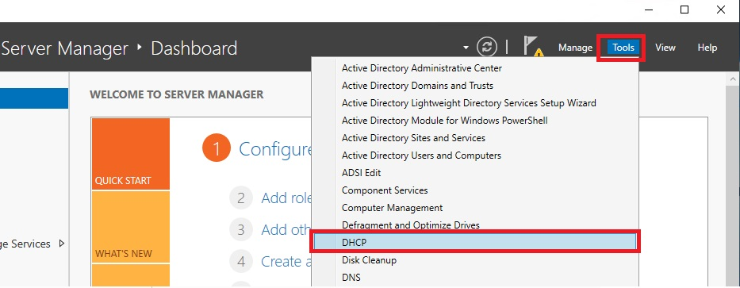

Now you should launch the DHCP Tools window.  
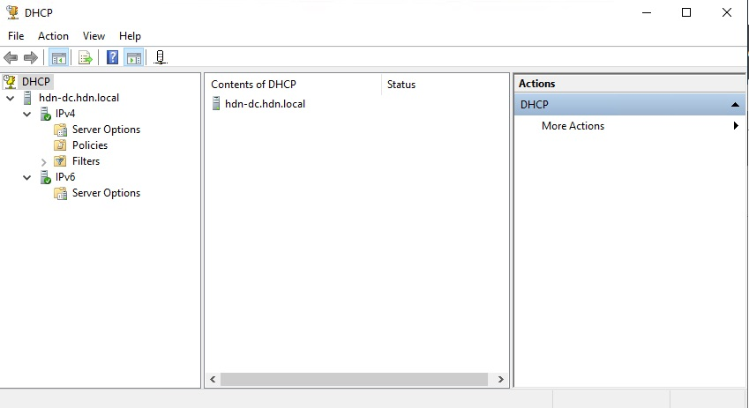

* **Right-click IPv4 and choose "New Scope."**…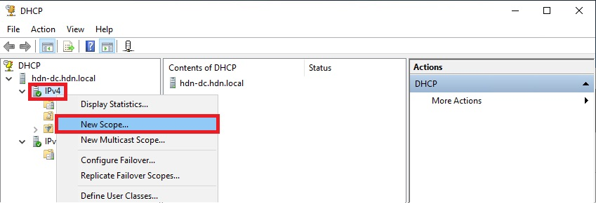
* Give your scope a name in the New Scope Wizard and then click Next.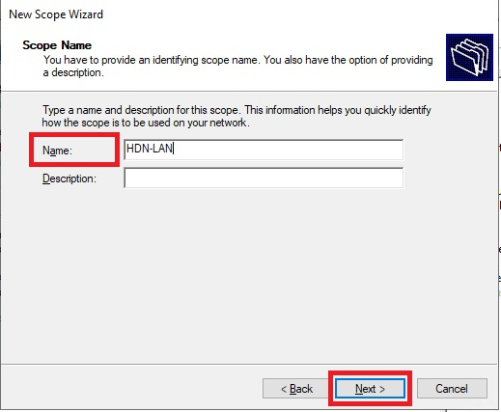
* Make that the DHCP Scope is on the same subnet as the default gateway and that it has a range.
* Click Next.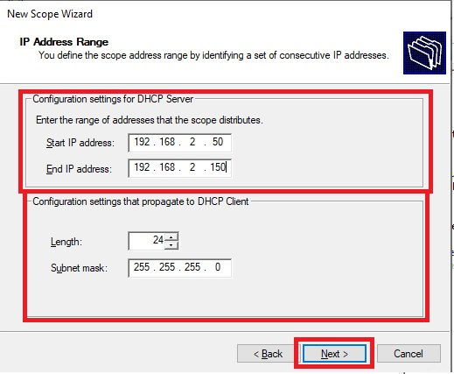
* Skip Delay and Exclusions.
* Select Next.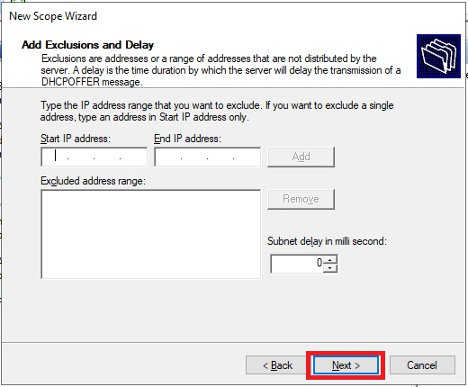
* Make sure the following options are chosen: Yes, I want to set up these options right away.
* Choose Next.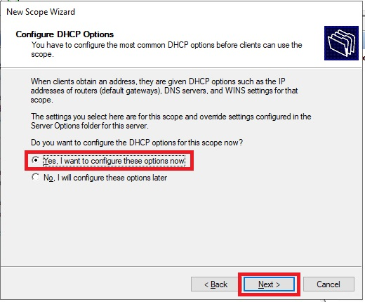
* Click Next after adding your default gateway's IP address.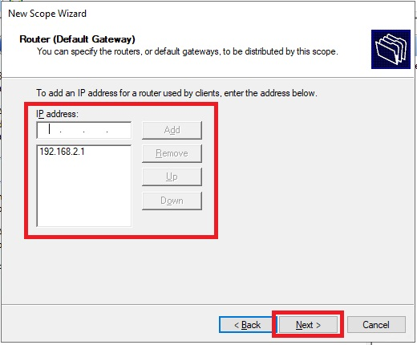
* Ensure that the Parent Domain is correctly configured.
* Give the name and IP address of the DNS server.
* Choose Next.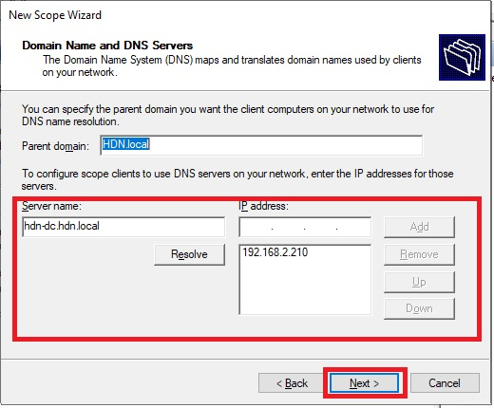
* Skip WINS
* Select Next**.**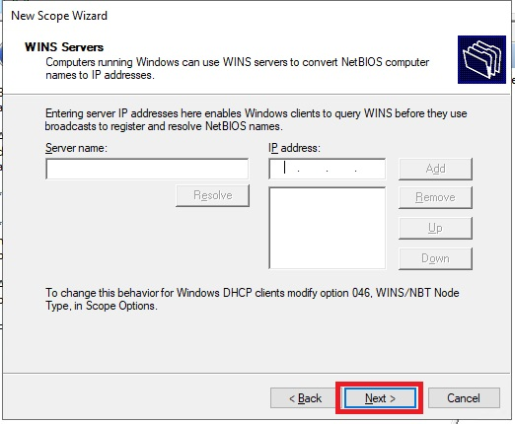
* Make certain you have: Yes, please activate this scope as it is currently selected.
* Visit Nex**t** (Domingues, 2023)**.**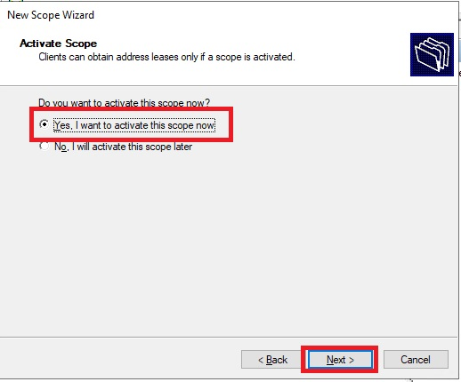

## Security measures implementation:

User Access Control

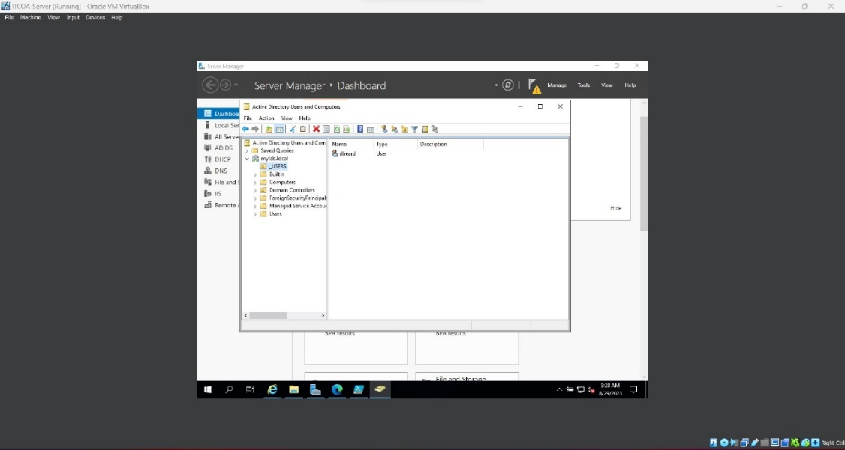

Logging into the Virtual Machine using a username and password

User access control for Midrand Threads Main Server

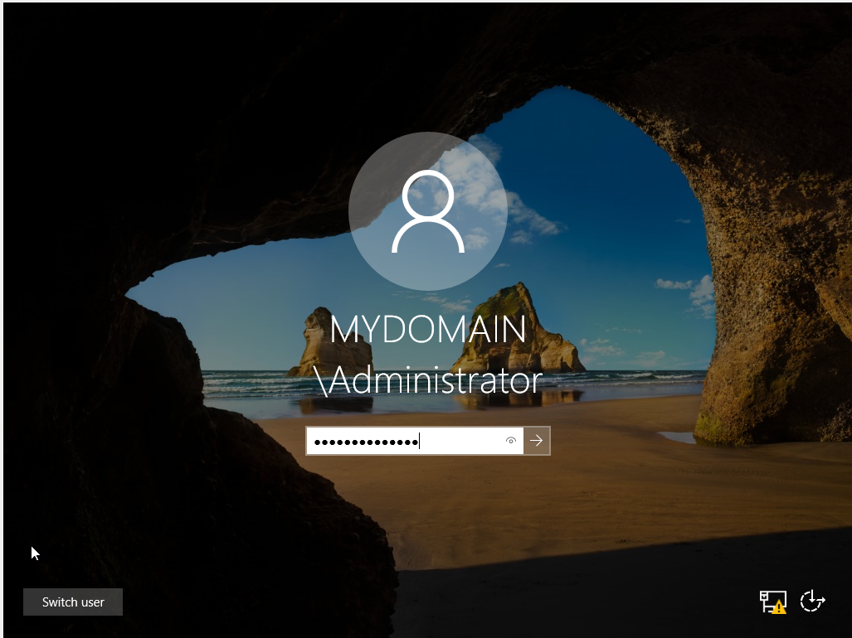z

User access control for Midrand Threads Client virtual machine.

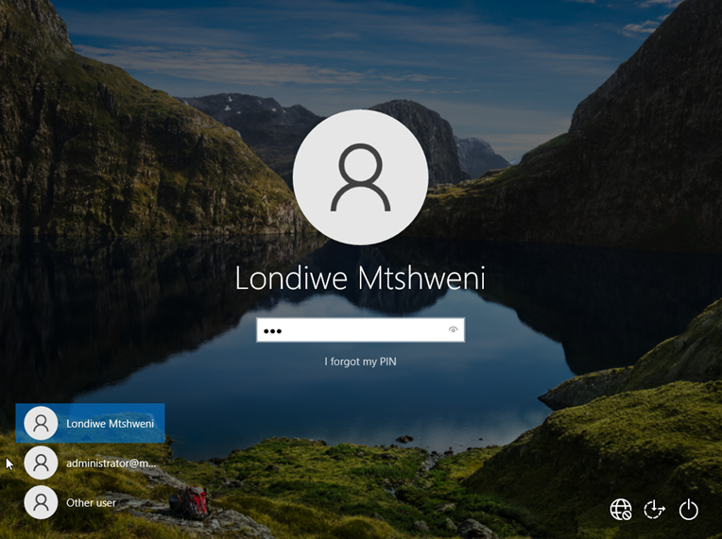

## Remote Access:

# Deliverable 3: Simulation and validation

## Connectivity Testing:

The image below shows the computers connected to the active directory, namely the client computers, MyProduction and MyManagement. From the server MyServer, we can ping each client from the server command prompt and receive the relevant feedback.

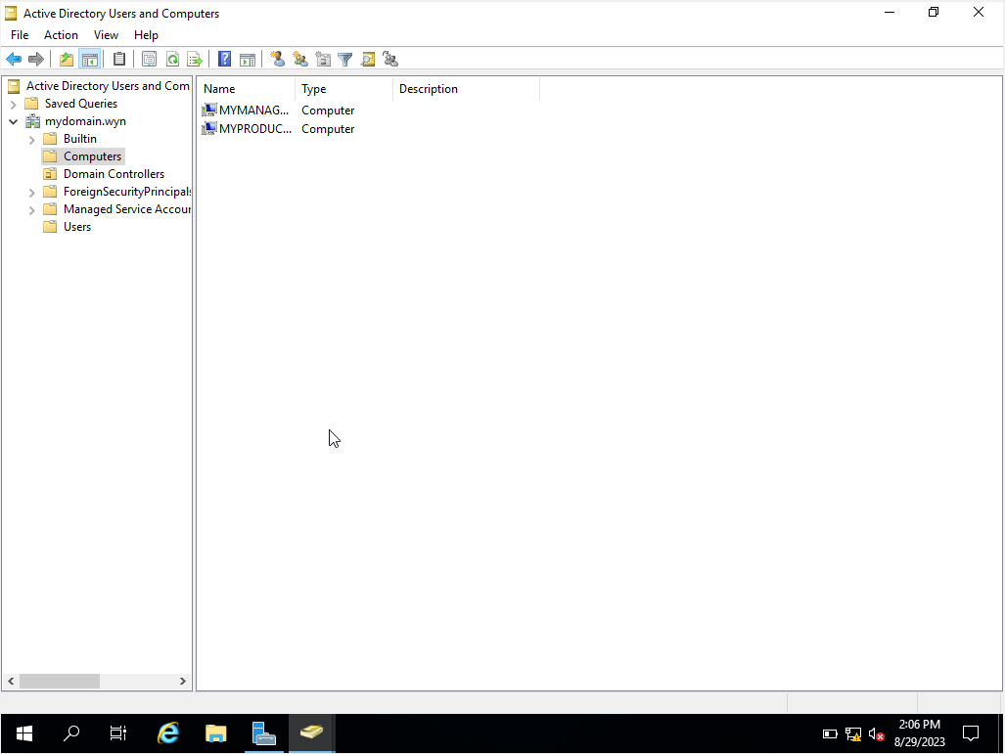

Ping Production from the server and Management from the Server:

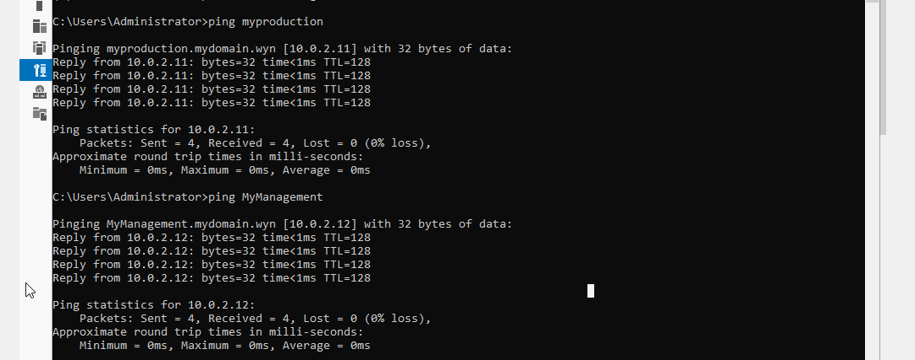

## DHCP, DNS and services functionality validation:

**DNS**

Internet connectivity:

DNS Validation:

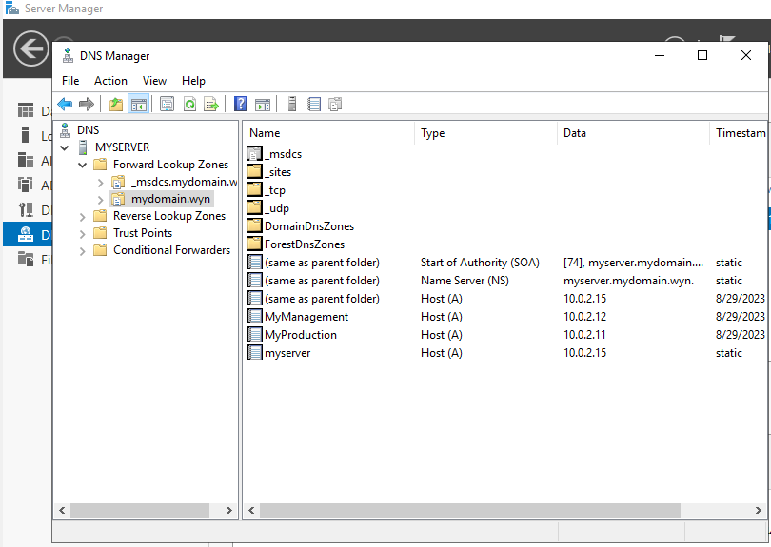

**DHCP**

According to the image below, the address pool for the domain mydomain is between IP addresses 10.0.2.10 and 10.0.2.50. For a DHCP to function successfully, the assigned IP addresses of the clients should be within the address pool. The configuration information for the clients production and management prove that the assigned IP addresses are within the scope.

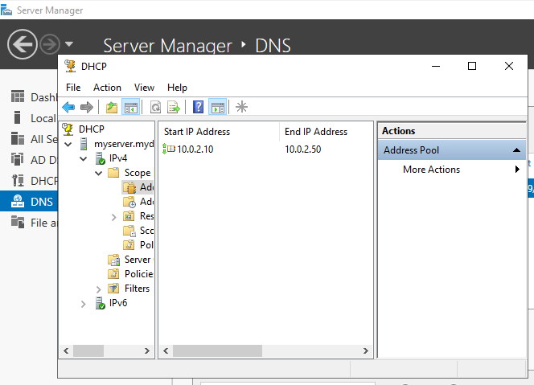

Management Client: (10.0.2.12)

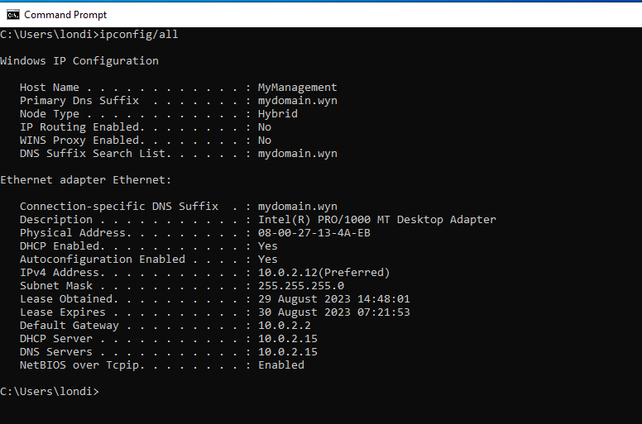

Production Client: (10.0.2.11)

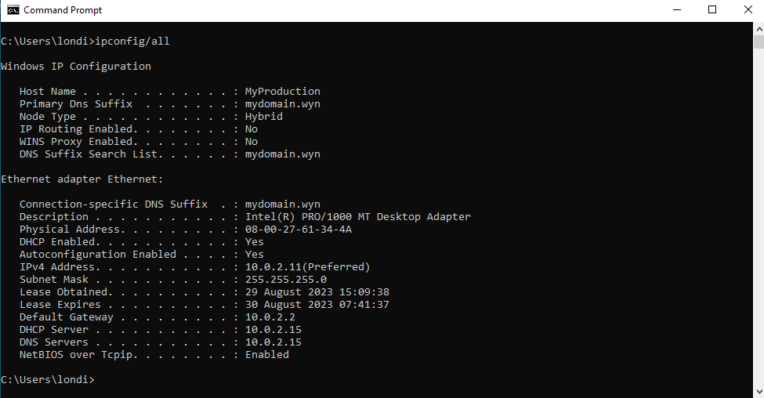

For further reference, the server MyServer was statically assigned with the IP address 10.0.2.15.

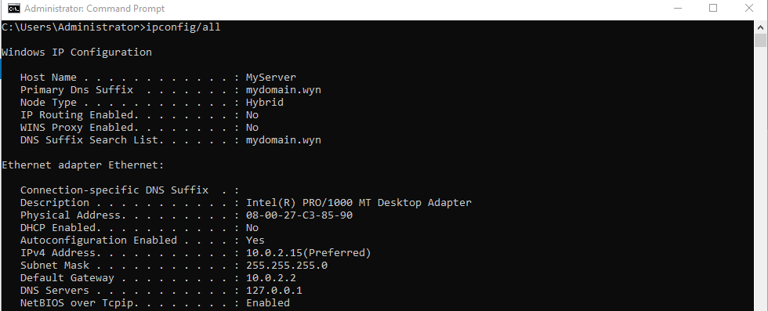

## Security Testing:

BitLocker Encryption

* The Windows disk encryption function Bitlocker is meant to safeguard data by encrypting whole volumes. The concerns of data theft or disclosure from lost, stolen, or improperly decommissioned devices are addressed by BitLocker. (Krause, 2019).
* BitLocker provides maximum protection when used with a Trusted Platform Module (TPM). A TPM is a hardware component installed in many devices and it works with BitLocker to help protect user data and to ensure that a computer hasn't been tampered with while the system is offline (Helleik Rabba Rise, 2022).

Combining BitLocker with a Trusted Platform Module ensures the highest level of security (TPM). In order to protect user data and make sure that a computer hasn't been tampered with while the system is offline, a TPM, a hardware component that is present in many devices, works with BitLocker. (Matarazzo, -).

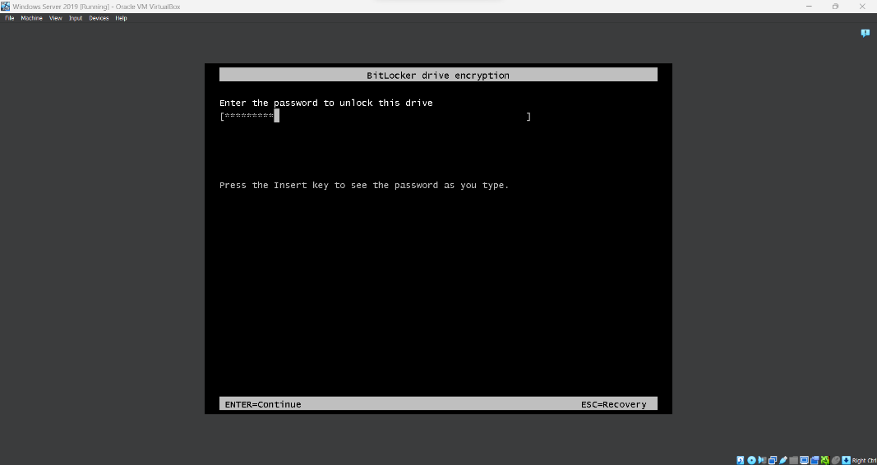

## Troubleshooting and issue resolution:

BitLocker security

* Missing TPM chip as a result of the virtual machine's hardware shortage.
* Change the encryption to password using a domain controller.

The Home edition of Windows 10 cannot connect to the domain.

* Windows 10 Pro, Education, Pro for Workstations, or Enterprise Edition are the only editions that support domain changes.
* Upgrades to the aforementioned editions are not possible without a product key.
* Reinstalling Windows 10 and making sure the edition is compatible with domain changes should fix the issue.

Cannot run both clients and server virtual machines simultaneously.

* Solved by running the server and one client at a time.

Server cannot ping a client from the server command prompt.

* By modifying the network and sharing center settings, the issue can be resolved while also enabling file and printer sharing and network discovery.

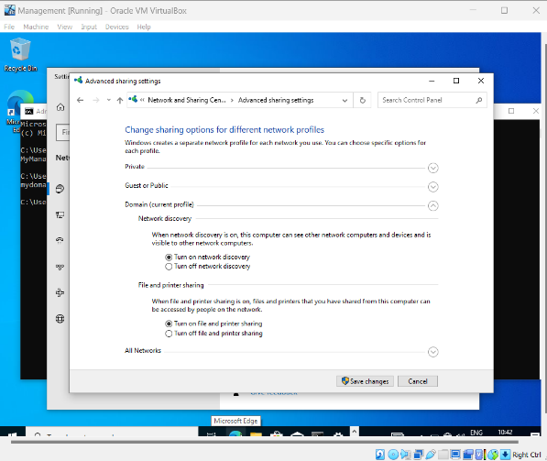

# Works Cited

A. Zakari, M. M. G. B. S. A. B. I. A. T. H. S. H., 2019. IPv4 and IPv6 Protocols: A Comparative Perfomance Study. In: -, ed. *Control and Systems Graduate Research Colloquium.* Shah Alam,Malaysia: -, pp. 1-4.

Bagci, T., 2022. *SYSNETTECH Solutions.* [Online]   
Available at: https://www.sysnettechsolutions.com/en/install-windows-server-2019-oracle-vm-virtualbox/  
[Accessed 29 August 2023].

Domingues, P., 2023. *How to Install and Configure Windows Server DHCP Role.* [Online]   
Available at: https://patrickdomingues.com/2022/02/05/how-to-install-and-configure-windows-server-dhcp-role/  
[Accessed 29 August 2023].

Helleik Rabba Rise, S. E., 2022. *Windows Server 2019/2022 and A Cloud security systems.* - ed. trondhein, Norway.: Hellik Raba Rise, Stian Engen.

Krause, J., 2019. Mastering Windows Server 2019. In: S. Editing, ed. *Mastering Windows Server 2019.* Birmingham: Packt Publishing Ltd, pp. 299-305.

Mark Henderson, J. K., 2020. *Windows Server 2019 Cookbook.* 2nd ed. Birmingham: Pakt Publishing.

Matarazzo, P., -. *Bitlocker Overview - Windows Security.* [Online]   
Available at: https://learn.microsoft.com/en-us/windows/security/operating-system-security/data-protection/bitlocker/  
[Accessed 29 August 2023].

Microsoft.com, -. *Windows server 2019.* [Online]   
Available at: https://www.microsoft.com/en-us/evalcenter/evaluate-windows-server-2019  
[Accessed 29 August 2023].

Roger, 2020. *Linux Windows and android Tutorials.* [Online]   
Available at: https://www.osradar.com/how-to-install-and-configure-a-dns-server-in-windows-server-2019-2016/  
[Accessed 29 August 2023].

Sidheeq, S., 2021. *GetLabsDone.* [Online]   
Available at: https://getlabsdone.com/how-to-install-windows-server-on-virtualbox/  
[Accessed 29 August 2023].